PROJECT REPORT
Summer Training — Power BI

Project Title | HR Attrition & Employee Overview Dashboard
Student Name | Ravish Sharma
Roll Number | 2419361
Course & Batch | B. Tech CSE (2028)
Department | Computer science & Engineering
Institute | CGC University
Training Period | 08/06/2026 TO 06/07/2026
Submission Date | 06/07/2026
Guided By | Mrs. Ashima & Mrs. Mandeep

1. Declaration

I hereby declare that the project report entitled “HR Attrition & Employee Overview Dashboard” submitted in partial fulfilment of the Summer Training Programme is an original piece of work carried out by me. The data used in this report has been collected from Kaggle. The dashboards, visuals shown in this report have been independently created by me in Microsoft Power BI Desktop.

I further confirm that this report or any part of it has not been submitted previously for any academic award.

Signature: ___________________________
Name: Ravish Sharma
Date: 06/07/2026

2. Abstract

This project presents an interactive HR Attrition and Employee Overview Dashboard developed using Microsoft Power BI to help organizations analyze employee turnover and identify factors affecting employee retention. The dashboard solves the business problem of understanding why employees leave the organization by providing insights into attrition patterns across departments, job roles, age groups, salary levels, and employee demographics.

The dataset used in this project is the IBM HR Analytics Employee Attrition dataset obtained from Kaggle. It contains 1,470 employee records and 35 attributes, including important fields such as Age, Department, Job Role, Monthly Income, Job Satisfaction, Years at Company, and Attrition status.

Power BI features such as Power Query for data cleaning and transformation, DAX measures for KPI calculations, and interactive visuals were applied to build the dashboard. Various charts, KPI cards, and slicers were created to provide an easy-to-understand view of employee data.

The final dashboard helps HR teams identify high attrition areas, compare employee turnover across departments, and understand factors influencing employee retention. It provides valuable insights that can support better HR decisions and improve employee satisfaction strategies.

3. Introduction

3.1 Background
- Human Resource Analytics helps organizations understand employee data and workforce trends.
- Data visualization makes HR data easier to analyze and helps identify attrition patterns.
- Dashboards help HR teams make better decisions related to employee retention and workforce management.

3.2 Problem Statement
- The project focuses on analyzing employee attrition and identifying reasons behind employee turnover.
- The target users of this dashboard are HR managers and decision-makers.
- Previously, analyzing large employee datasets manually made it difficult to find attrition trends.
- The dashboard helps identify departments, job roles, age groups, and salary levels with higher attrition.
- It enables organizations to make better decisions for improving employee retention and satisfaction.

3.3 Objectives
- Clean and transform the IBM HR Analytics dataset using Power Query.
- Handle missing values, data types, and prepare data for analysis.
- Create an effective data model for better visualization and reporting.
- Develop DAX measures such as:
  - Total Employees
  - Employees Left
  - Attrition Rate
- Create interactive Power BI visuals using charts, KPI cards, and slicers.
- Analyze attrition based on department, job role, age group, salary, and other employee factors.

4. Dataset Description

4.1 Data Source

Source Name | Kaggle
Dataset Name | IBM HR Analytics Employee Attrition & Performance
File Format | CSV
Number of Records | 1470
Number of Columns | 35
Time Period Covered | Not Specified
Download Link | https://www.kaggle.com/datasets/pavansubhasht/ibm-hr-analytics-attrition-dataset

4.2 Key Fields / Columns
List and describe the important columns used in analysis:

Column Name | Data Type | Description / Role in Analysis
Employee Number | Integer | Unique identifier for each employee
Age | Integer | Used for age group analysis and attrition comparison
Attrition | Text | Main Column used to identify employee who left the company
Department | Text | Used for Department-wise attrition analysis
Gender | Text | Used for demographics analysis
Years At Company | Integer | Shows employee experience and retention analysis
Job Role | Text | Helps analyze salary impact on employee turnover

4.3 Data Quality Issues & Cleaning Step
- Data Quality Check : Checked Dataset for missing Values and no significant null value.
- Handled null values — Checked all columns for null Values and replacing blanks where required.
- Changed data types — convert column in appropriate data type such as integer, text, decimal.
- Renamed Columns — Updated column names where required to improve readability & understanding.
- Created calculated columns — Created additional fields such as age group and salary category for better visualization and analysis
- Data validation – Verified that the cleaned dataset was accurate and ready for Power BI visuals.

5. Data Modelling

5.1 Schema Design

Schema Type | Star Schema
Employee Fact Table | – (Employee count, Monthly Count, Years at company, Job-Satisfaction)
Employee Dimension | – (Age, Gender, Education, Marital Status, Employee Number)
JOB Dimension | --[Department, Job role, Job Level, Business travel, Overtime]
Salary & Experience Dimension | --[Monthly Income, Precent Salary Hike, Years at Company, Total Working Days]
Relationships | All dimension tables joined to Fact table using EmployeeNumber; One-to-Many; Single filter direction

5.2 Model Diagram
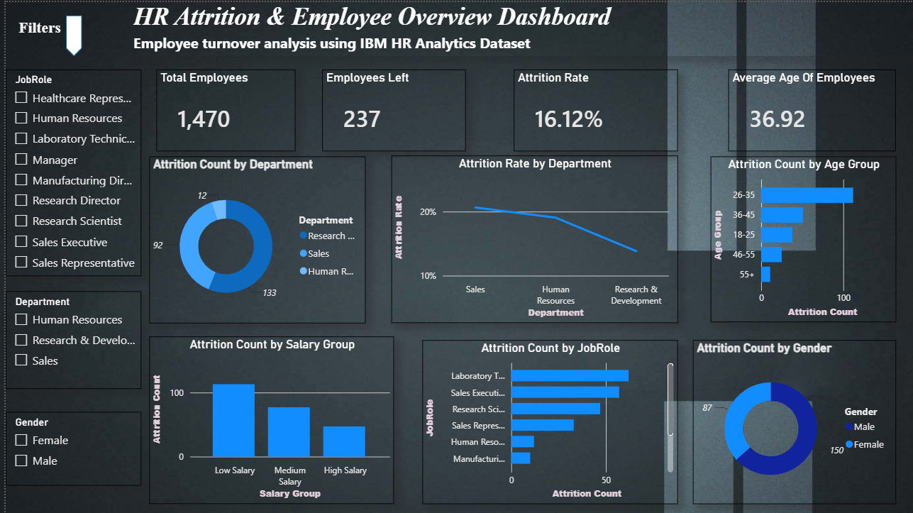

6. Dashboard & Visuals

Describe each page / view in your Power BI report. Include a screenshot of each page.

6.1 Page 1 — Summary / Overview
Visuals used on this page:
- KPI Cards — Employee Count, Attrition Rate, Average Age
- Bar Chart — Attrition By Job Role
- Column Chart — Attrition By Age Group
- Pie Chart — Attrition By Gender
- Donut Chart — Attrition Count By Department
- Slicer — Department / Job Role / Gender

“The Dashboard shows that employee attrition is higher in certain departments and job roles. Younger Employee with lower job satisfaction show higher chances of leaving the organization”

6.2 Drill-through Page
Drill-through filter used: DEPARTMENT /JOB ROLE
What this page shows:
- This page provides detailed analysis of selected department or job role from the main dashboard.
- It shows employee count, attrition count, attrition rate, average salary, age distribution, and satisfaction level.
- Users can right-click on any department or job role in the main dashboard to view detailed employee insights.

7. Key Findings & Insights

Finding 1:
- The dashboard shows that the overall employee attrition rate is around 16%, indicating that a significant number of employees have left the organization.
Finding 2:
- Employees in certain departments show higher attrition compared to others, helping HR identify departments that need better retention strategies.
Finding 3:
- Employees with lower job satisfaction levels have a higher tendency to leave the organization, showing a relationship between satisfaction and attrition.
Finding 4:
- Younger employees and employees with fewer years at the company contribute more to attrition, indicating challenges in early employee retention.
Finding 5:
- Employees working overtime show higher attrition rates compared to employees without overtime, suggesting workload may impact employee retention.
Finding 6:
- The dashboard helps HR teams identify key attrition factors and supports data-driven decisions for improving employee satisfaction and retention.

8. Learnings & Challenges

8.1 Skills Learned
- Learned data cleaning and transformation using Power Query.
- Created DAX measures for HR metrics and KPIs.
- Built interactive dashboards using Power BI visuals and slicers.
- Analyzed employee attrition patterns using data insights.
- Improved data modeling and visualization skills.

8.2 Challenges Faced
- Cleaning and preparing the raw HR dataset for accurate analysis.
- Handling data types and missing values during Power Query transformation.
- Creating correct DAX measures for calculating attrition rate and KPIs.
- Designing visuals to clearly represent employee attrition insights.
- Understanding data relationships and improving dashboard performance.

9. Conclusion

This project successfully addresses the problem of analyzing employee attrition using an interactive HR Attrition Dashboard developed in Power BI. The dashboard helps HR managers understand employee turnover patterns and identify factors affecting retention, such as department, job role, age, salary, and satisfaction level.
It provides a simple and effective way to view important HR insights through KPI cards, charts, and filters instead of manually analyzing large datasets. The dashboard supports better decision-making by helping organizations develop strategies to improve employee satisfaction and reduce attrition.
If given more time, the project could be improved by adding predictive analysis, employee risk prediction, and advanced AI-based insights. This training project enhanced my skills in Power Query, DAX, data modelling, and Power BI dashboard development

10. References

- Microsoft Power BI Documentation
https://docs.microsoft.com/en-us/power-bi/
- Dataset Source: IBM HR Analytics Employee Attrition Dataset (Kaggle)
https://www.kaggle.com/datasets/pavansanagapati/ibm-hr-analytics-attrition-dataset
- DAX Reference Guide
https://dax.guide/
- Power Query M Reference
https://docs.microsoft.com/en-us/powerquery-m/
- Microsoft Learn – Power BI Training Resources
https://learn.microsoft.com/en-us/training/powerplatform/power-bi/
- OpenAI ChatGPT was used for assistance in understanding Power BI concepts and improving project documentation.
https://chat.openai.com
END OF REPORT

